BRAIN TUMOUR DETECTION
By
A.ROHITHA-17BLC1007
K.MADHU SWAPNIKA-17BLC1024

A project report submitted to
Dr. MohanaPrasad.K Sir
SCHOOL OF ELECTRONICS ENGINEERING
in partial fulfilment of the requirements for the course of
ECE(1004)-Signals and systems
in
B.Tech. ELECTRONICS ENGINEERING

Vellore Institute of Technology (VIT) CHENNAI
Vandalur – Kelambakkam Road
Chennai – 600127
MARCH,2018

BONAFIDE CERTIFICATE

Certified that this project report entitled “BRAIN TUMOUR DETECTION”is a bonafide work of A.ROHITHA(17BLC1007), K.MADHU SWAPNIKA(17BLC1024),who carried out the Project work under my supervision and guidance.

Dr. MohanaPrasad.K
Associate Professor
School of Electronics Engineering (SENSE),
VIT University, Chennai
Chennai – 600 127.

ABSTRACT
Tumor detection and removal is one medical issue that still remains challenging in the field of biomedicine. Early imaging techniques such as pneumoencephalography and cerebral angiography had the drawback of being invasive and hence the CT and MRI imaging techniques help the surgeons in providing a better vision. In this paper, tumor image processing involves three stages namely pre-processing, segmentation and morphological operation. After the acquisition of the source image, it is pre-processed by converting the original image to gray scale in addition high pass filter for noise removal and median filter for quality enhancement is provided which is followed by enhancement stage resulting with histo gramic equivalent image. Finally segmentation is done by means of watershed algorithm. The above proposed methodology is helpful in generating the reports automatically in less span of time and advancement has resulted in extracting many inferior parameters of the tumor.

ACKNOWLEDGEMENT

We wish to express our sincere thanks and deep sense of gratitude to our project guide,Dr.MohanaPrasad.K Sir, Associate Professor, School of Electronics Engineering, for his consistent encouragement and valuable guidance offered to us in a pleasant manner throughout the course of the project work.
We are extremely grateful to Dr.Sreedevi. V.T, Dean of the School of Electronics Engineering, VIT Chennai, for extending the facilities of the School towards our project and for her unstinting support.
We express our thanks to our Programme Chair Dr.Susan Elias and Co-Chair Prof.ReenaMonica.Pfortheir support throughout the course of this project.
We also take this opportunity to thank all the faculty of the School for their support and their wisdom imparted to us throughout the course. We thank our parents, family, and friends for bearing with us throughout the course of our project and for the opportunity they provided us in undergoing this course in such a prestigious institution.
ROHITHA MADHU SWAPNIKA

TABLE OF CONTENTS

SERIAL NO. |  | NAME | PAGE NO.
 |  | ABSTRACT | 3
 |  | ACKNOWLEDGEMENT | 4
1 |  | INTRODUCTION | 5
 | 1.1 | OBJECTIVES AND GOALS | 5
 | 1.2 | BENEFITS | 5
 | 1.3 | TUMOUR | 5
2 |  | DESIGN | 6-7
 | 2.1 | ALGORITHM | 6
 | 2.2 | METHODOLOGY | 7
3 | PREPROCESSING  3.1 | CONVERSION TO GRAY SCALE | 8-9  8
 | 3.2  3.3 | FILTERING  IMAGE ENHANCING BY SUBTRACTION. | 8  9
4 | PROCESSING |  | 9-10
 | 4.1 | THRESHOLD SEGMENTATION | 9
 | 4.2  4.3 | WATERSHED SEGMENTATION  MORPHOLOGICAL  OPERATORS AND PROGRAM CODE | 9  10-13
5 OUTPUT AND REFERENCES 13-15

1.INTRODUCTION

1.1 OBJECTIVES AND GOALS
- To Detect the size and location of brain tumours and edemas from the magnetic resonance images .
- The main objective is to detect and segment the brain tumour using watershed and thresholding algorithm.
- we are proposing an automatic brain tumour detection system selecting a suitable segmentation method.
1.2 BENEFITS
To examine the location of tumor in the brain, Magnetic Resonance Imaging (MRI) is used. Radiologists will evaluate the grey scale MRI images. This procedure is really time and energy consuming. This project presents a review of various techniques proposed for segmenting an MRI image which comparatively take lesser time than manual operations to detect and extract the brain tumor. A brain tumor is a primary or secondary type depending on its location of origin.
1.3 TUMOUR:
A tumour or tumour is the name for a neoplasm or a solid lesion formed by an abnormal growth of cells (termed neoplastic) which looks like a swelling.Tumor is not synonymous with cancer. A tumor can be benign, pre-malignant or malignant, whereas cancer is by definition malignant.
TYPES OF TUMOR:
A benign tumor is a tumor that lacks all three of the malignant properties of a cancer. Thus, by definition, a benign tumor does not grow in an unlimited, aggressive manner, does not invade surrounding tissues, and does not spread to non-adjacent tissues (metastasize). Common examples of benign tumors include moles and uterine fibroids.
MALIGNANT :
Malignancy (from the Latin roots mal- = &quot;bad&quot; and -ignis = &quot;fire&quot;) is the tendency of a medical condition, especially tumors, to become progressively worse and to potentially result in death. It is characterized by the properties of anaplasia, invasiveness, and metastasis. Malignant is a corresponding adjectival medical term used to describe a severe and progressively worsening disease. The term is most familiar as a description of cancer.
PREMALIGNANT :
A precancerous condition (or premalignant condition) is a disease, syndrome, or finding that, if left untreated, may lead to cancer. It is a generalized state associated with a significantly increased risk of cancer.
MRI:
Magnetic resonance imaging (MRI), or nuclear magnetic resonance imaging (NMRI), is primarily a medical imaging technique used in radiology to visualize detailed internal structure and limited function of the body. MRI provides much greater contrast between the different soft tissues of the body than computed tomography (CT) does, making it especially useful in neurological (brain), musculoskeletal, cardiovascular, and oncological (cancer) imaging. Unlike CT, MRI uses no ionizing radiation. Rather, it uses a powerful magnetic field to align the nuclear magnetization of (usually) hydrogen atoms in water in the body. Radio frequency (RF) fields are used to systematically alter the alignment of this magnetization. This causes the hydrogen nuclei to produce a rotating magnetic field detectable by the scanner. This signal can be manipulated by additional magnetic fields to build up enough information to construct an image of the body.
2.1 ALGORITHM
MRI/CT images of the brain are processed, for the detection of tumor using MATLAB. The Methodologies employed here are
Algorithm Used for Detection for Tumor:
Step 1: Input the image
Step 2: Convert the RGB image to grey.
Step 3: Use the filters for removing noise and perform subtraction operation and form histogramic equivalent for Contrast enhancement.
Step 4: Apply Watershed Segmentation for tumor.
Step 5: Perform morphological operations for calculating Area, Third moment, Entropy, Mean, Standard Deviation.
2.2 METHODOLOGY
The part of the image containing the tumor normally has more intensity then the other portion and we can assume the area, shape and radius of the tumor in the image. We have used these basic conditions to detect tumor in our code and the code goes through the following steps.
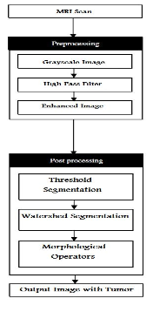

3. PREPROCESSING
Image pre-processing aims to improve the image data by suppressing the undesired distortions and enhances some of the image features that will be helpful in further processing. The goal of Pre-processing is to remove the noise and to provide Contrast Enhancement to improve the image quality. The functions performed by preprocessing process is Gray scale conversion Noise removal Contrast Enhancement
3.1. Conversion to Gray Scale: A grayscale image only consists of gray scale values, but MRI images consist of primary colors (RGB) content. A ‘Gray’ color is one in which the red, green and blue components all have equal intensity in RGB space and so it is only necessary to specify a single intensity value for each pixel, as opposed to the three intensity values needed to b specified for each pixel in a full color image .when MRI/CT images are viewed ,they look like black and white but they contain some primary colors (RGB).So ,for further processing of MRI/CT brain image ,it must be converted to perfect grayscale image.
3.2.Filtering: Filtering is a technique used for eliminating the noise present in an image. The median filter that provides median values of the pixels are used because the mean values obtained using averaging filters results in blurring of the image. In MRI, Gaussian and salt and pepper noise are more predominant. Salt and Pepper noise can be eliminated by median filter, whereas Gaussian noise is eliminated by a Gaussian high pass filter.
Gaussian High Pass Filter: It is done to sharpen the image. A high pass filter preserves the high frequency information within an image while reducing the low frequency information, thus emphasizing the transitions in the image intensities. In high pass filtering, the brightness of the centre pixel is increased relative to its neighboring pixels by the kernel of the filter. The kernel array consists of a single positive value at its centre, which is completely surrounded by negative values. Figure 4 shows the after applied Gaussian HP filter image. Median Filter: The median filter is used to reduce the salt and pepper noise present due to motion artifacts (movement of patient during scan) in the CT/MRI images. It is done for smoothening of CT/ MRI brain image. Here we are using 25x25(CT) and 15x15 (MRI) median filter to eliminate salt and pepper noise.
3.3. Image Enhancing by Subtraction: Image enhancement provides the details that are obscured and highlight certain features in an image. The fundamental enhancement needed in the CT/MRI images is the contrast enhancement. In this paper we perform subtraction operation and histogramic equivalent formation for enhancing the contrast of CT/MRI brain image. Subtraction operation is performed on a pixel by pixel basis sequentially, one pixel at a time, or in parallel, where all operations are performed simultaneously.
4.PROCESSING:
In processing the following different steps are followed:-
4.1. THRESHOLD SEGMENTATION:
Segmentation is done on basis of a threshold, due to which whole image is converted into binary image. Basic matlab commands for thresholding are used for this segmentation.
4.2. WATERSHED SEGMENTATION:
It is the best method to segment an image to separate a tumor but it suffers from over and under segmentation, due to which we have used it as a check to our output. We have not used watershed segmentation on our input, rather it is only used on our output to check of the result is correct or not and it give the correct answer every time as is shown below.
4.3. MORPHOLOGICAL OPERATORS:
After that some morphological operations are applied on the image after converting it into binary form. The basic purpose of the operations is to show only that part of the image which has the tumor that is the part of the image having more intensity and more area then that specified in the strel command.
The basic commands used in this step are strel, imerode and imdilate.

Imerode():
It is used to erode an image.

Imdilate():
It is used to dilate an image.
Program-code:
function varargout = PROJECT(varargin)
gui_Singleton = 1;
gui_State = struct('gui_Name', mfilename, ...
'gui_Singleton', gui_Singleton, ...
'gui_OpeningFcn', @PROJECT_OpeningFcn, ...
'gui_OutputFcn', @PROJECT_OutputFcn, ...
'gui_LayoutFcn', [] , ...
'gui_Callback', []);
if nargin && ischar(varargin{1})
gui_State.gui_Callback = str2func(varargin{1});
end

if nargout
[varargout{1:nargout}] = gui_mainfcn(gui_State, varargin{:});
else
gui_mainfcn(gui_State, varargin{:});
end
function PROJECT_OpeningFcn(hObject, eventdata, handles, varargin)
handles.output = hObject;
guidata(hObject, handles);
function varargout = PROJECT_OutputFcn(hObject, eventdata, handles)
varargout{1} = handles.output;
function pushbutton1_Callback(hObject, eventdata, handles)
global img;
global bw;
global bw5;
global img_gray;
img_gray=rgb2gray(img);
axes(handles.axes2);
imshow(img_gray);
[r c]=size(img_gray);
b=zeros(r,c);
hp_fil=[-1 2 -1;0 0 0;1 -2 1];
b=imfilter(img_gray,hp_fil);
axes(handles.axes4);
imshow(b);
c=b+img_gray+25;
medfilt2(c);
axes(handles.axes6);
imshow(c);
T = graythresh(c);
bw = im2bw(c,T+0.3);
axes(handles.axes3);
imshow(bw);
bw5=watershed(bw);
axes(handles.axes5);
imshow(bw5);

function slider1_Callback(hObject, eventdata, handles)
function slider1_CreateFcn(hObject, eventdata, handles)
if isequal(get(hObject,'BackgroundColor'), get(0,'defaultUicontrolBackgroundColor'))
set(hObject,'BackgroundColor',[.9 .9 .9]);
end
function pushbutton2_Callback(hObject, eventdata, handles)
global img;
global bw;
global bw5;
global img_gray;
global bw3;
fs = get(0,'ScreenSize');
figure('Position',[0 0 fs(3)/2 fs(4)])
SE = strel('disk',0);
bw1 = imerode(bw,SE);
subplot(3,2,1);
imshow(bw1);
SE = strel('disk',0);
bw1 = imdilate(bw1,SE);
subplot(3,2,2);
imshow(bw1);
SE2 = strel('disk',1);
bw2 = imerode(bw1,SE2);
subplot(3,2,3);
imshow(bw2)
SE2 = strel('disk',1);
bw2 = imdilate(bw2,SE2);
subplot(3,2,4);
imshow(bw2)
SE3 = strel('disk',6);
bw3 = imerode(bw2,SE3);
subplot(3,2,5);
imshow(bw3)

SE3 = strel('disk',6);
bw3 = imdilate(bw3,SE3);
subplot(3,2,6);
imshow(bw3)
function pushbutton3_Callback(hObject, eventdata, handles)
global img;
global bw;
global bw5;
global img_gray;
global bw3;
fs = get(0,'ScreenSize');
figure('Position',[round(fs(3)/2) 0 fs(3)/2 fs(4)])

[r2 c2]=size(bw3);

for i=1:1:r2
for j=1:1:c2
if bw3(i,j)==1
img_gray(i,j)=255;
else
img_gray(i,j)=img_gray(i,j)*0.5;
end;
end;
end;
subplot(2,1,1);
imshow(img);
subplot(2,1,2);
imshow(img_gray);
function slider3_Callback(hObject, eventdata, handles)
ts=get(handles.slider3,'value');
global img;
if (ts==.05)

img=imread('img1.jpg');
end
if (ts== .1)
img= imread('img2.jpg')
end
if (ts== .15)
img= imread('img3.jpg')
end
if (ts== .2)
img= imread('img4.jpg')
end
if (ts== .25)
img= imread('img5.jpg')
end
if (ts== .3)
img= imread('img6.jpg')
end
if (ts== .35)
img= imread('img7.jpg')
end
if (ts== .4)
img= imread('img8.jpg')
end
if (ts== .45)
img= imread('img9.jpg')
end
if (ts== .5)
img= imread('img10.jpg')
end
if (ts== .55)
img= imread('img11.jpg')
end
if (ts== .6)
img= imread('img12.jpg')
end
if (ts== .65)
img= imread('img13.jpg')
end
if (ts== .7)
img= imread('img14.jpg')
end
if (ts== .75)
img= imread('img15.jpg')
end

axes(handles.axes1);
imshow(img);
function slider3_CreateFcn(hObject, eventdata, handles)
if isequal(get(hObject,'BackgroundColor'), get(0,'defaultUicontrolBackgroundColor'))
set(hObject,'BackgroundColor',[.9 .9 .9]);
end

5. OUTPUTS/RESULTS:
We have mapped the resultant tumor image onto the original grayscale image for presentation purposes.
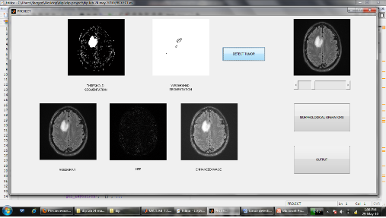
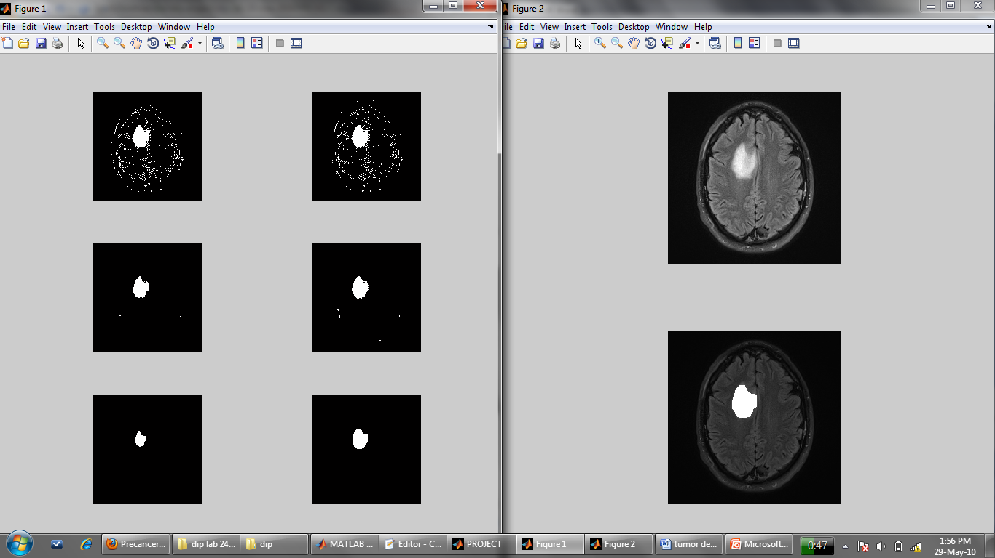
OTHER RESULTS:

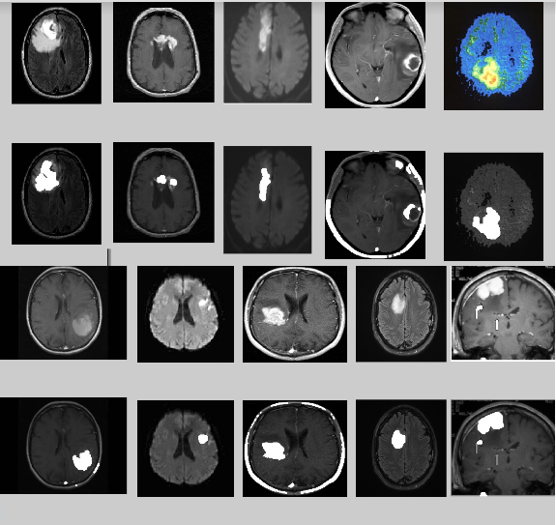
REFERENCES:
https://www.medicinenet.com/brain_tumor/article.html
https://in.mathworks.com/help/images/morphological-dilation-and-erosion.html
https://in.mathworks.com/discovery/image-segmentation.html
https://in.mathworks.com/help/images/ref/im2bw.html
https://in.mathworks.com/help/images/examples/marker-controlled-watershed-segmentation.html

